s

**PROFILE**

Microbiology

student.

I consider my self a

responsible and orderly

person.

I am looking foward for

my first work

experience.

**CONTACT ME**

+2348145122662

Yusuf.barakat2000@gmail.com

No. 78, Mokin street,

Erin osun, Osun state,

Nigeria.

**VOLUNTEER EXPERIENCE**

**JAKFEM PHARMACY & SUPERMARKET**

Participation in sales representative.

MOFETT PHARMACY & SUPERMARKET LTD.

**EDUCATION**

FEDERAL UNIVERSITY OF TECHNOLOGY, MINNA

*Microbiology, in*

*progress.*

**FAMOUS PRINCE INT. SCHOOL**

*2011-2017*

**LANGUAGE**

English.

Yoruba

**COMPUTER SKILLS**

Web Development

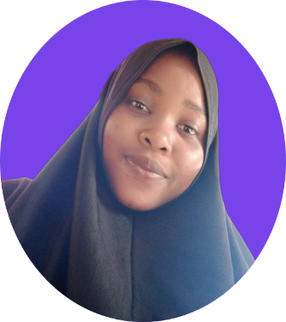

**BARAKATT**

**YUSUF**

*Student*

Slide presentation.